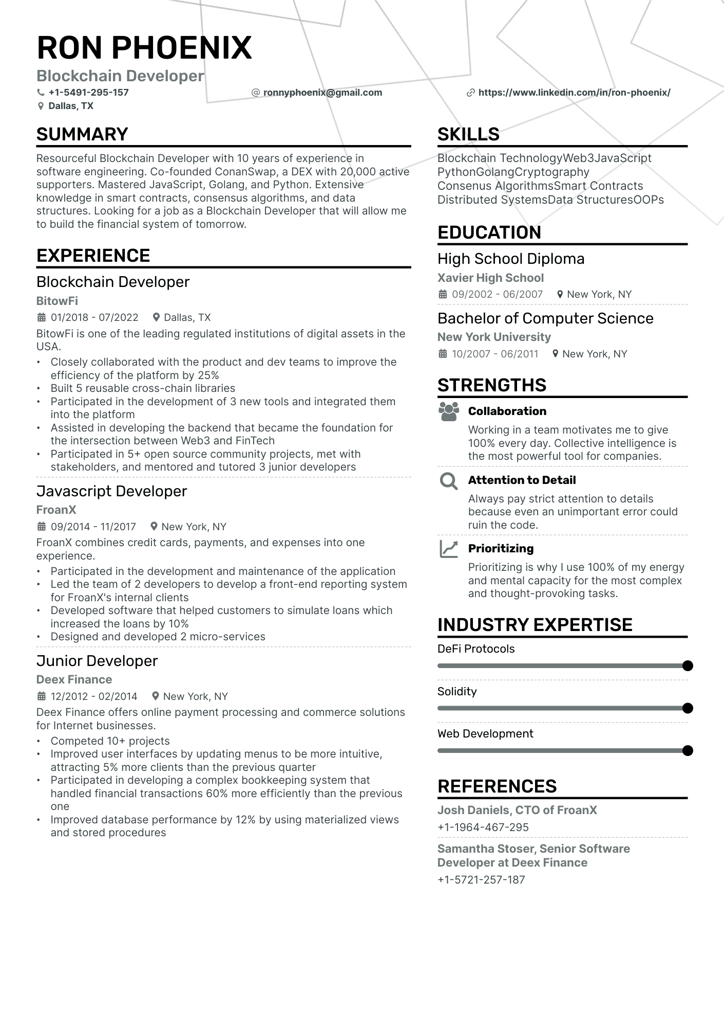
RON PHOENIX
Blockchain Developer
+1-5491-295-157 Dallas, TX
SUMMARY
@ronnyphoenix@gmail.com
Resourceful Blockchain Developer with 10 years of experience in software engineering. Co-founded ConanSwap, a DEX with 20,000 active supporters. Mastered JavaScript, Golang, and Python. Extensive knowledge in smart contracts, consensus algorithms, and data structures. Looking for a job as a Blockchain Developer that will allow me to build the financial system of tomorrow.
EXPERIENCE
Blockchain Developer
BitowFi
01/2018 07/2022
Dallas, TX
BitowFi is one of the leading regulated institutions of digital assets in the USA.
•
·
•
Closely collaborated with the product and dev teams to improve the efficiency of the platform by 25%
Built 5 reusable cross-chain libraries
Participated in the development of 3 new tools and integrated them into the platform
Assisted in developing the backend that became the foundation for
the intersection between Web3 and FinTech
Participated in 5+ open source community projects, met with stakeholders, and mentored and tutored 3 junior developers
Javascript Developer
FroanX
09/2014 11/2017
New York, NY
FroanX combines credit cards, payments, and expenses into one experience.
•
Participated in the development and maintenance of the application Led the team of 2 developers to develop a front-end reporting system for FroanX's internal clients
Developed software that helped customers to simulate loans which increased the loans by 10%
Designed and developed 2 micro-services
Junior Developer
Deex Finance
12/2012 02/2014
New York, NY
Deex Finance offers online payment processing and commerce solutions for Internet businesses.
https://www.linkedin.com/in/ron-phoenix/
SKILLS
Blockchain TechnologyWeb3JavaScript
PythonGolangCryptography
Consenus AlgorithmsSmart Contracts Distributed Systems Data StructuresOOPs
EDUCATION
High School Diploma Xavier High School
09/2002 06/2007
New York, NY
Bachelor of Computer Science
New York University
10/2007 - 06/2011 New York, NY
STRENGTHS
Collaboration
Working in a team motivates me to give 100% every day. Collective intelligence is the most powerful tool for companies.
Attention to Detail
Always pay strict attention to details because even an unimportant error could ruin the code.
Prioritizing
Prioritizing is why I use 100% of my energy and mental capacity for the most complex and thought-provoking tasks.
INDUSTRY EXPERTISE
DeFi Protocols
Solidity
Web Development
•
Competed 10+ projects
.
Improved user interfaces by updating menus to be more intuitive, attracting 5% more clients than the previous quarter
•
Participated in developing a complex bookkeeping system that handled financial transactions 60% more efficiently than the previous
one
Improved database performance by 12% by using materialized views and stored procedures
REFERENCES
Josh Daniels, CTO of FroanX +1-1964-467-295
Samantha Stoser, Senior Software Developer at Deex Finance
+1-5721-257-187

